Release Note – **Hook creation on project import**

Quarterly Product Release

Version 24.1.0.0



C

ONTACTS

info@uppwise.com

[LinkedIn Company Profi](https://www.linkedin.com/company/uppwise)le

[www.uppwise.c](http://www.uppwise.com/)om

Quarterly Product Release Version 23.3.0.1



C

ONTACTS

info@uppwise.com

[LinkedIn Company Profi](https://www.linkedin.com/company/uppwise)le

[www.uppwise.c](http://www.uppwise.com/)om

This serves as a Feature Release Note to apprise our customers of the latest addition to the application, released with the Uppwise 2024 **Quarter 1 release 24.1.0.0**

# Feature: Hook creation on project import

We are excited to announce the release of our latest feature development aimed at streamlining the project initiation process: the Project Upload Process. This new functionality allows users to effortlessly upload Excel files to create projects and associated information, simplifying data input and ensuring accuracy.

* **Extension Hook:** A new External API has been created to incorporate client-specific logic, triggered via the External Hook.
* **Upload Custom Excel File**: Users can initiate the process by uploading an Excel file containing project details. The file serves as a comprehensive input document, capturing essential information for project creation. If the hook is enabled, a message will indicate that the upload is being done by an external service.
* **Asynchronous Processing:** The process is executed asynchronously to accommodate large data imports efficiently.
* **Read-Only Mode:** During the import process, a global flag will be raised, indicating that the project is in read-only mode. Users will be notified of this status within the workspace.

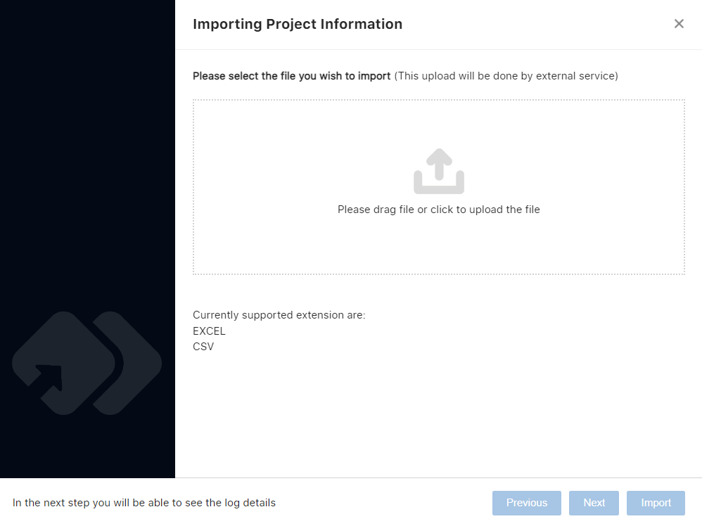

**Log Details and Outcome Download:**

After importing the file, users can review log details to ensure successful importation. Additionally, users have the option to download the outcome in Excel format through the provided icon.

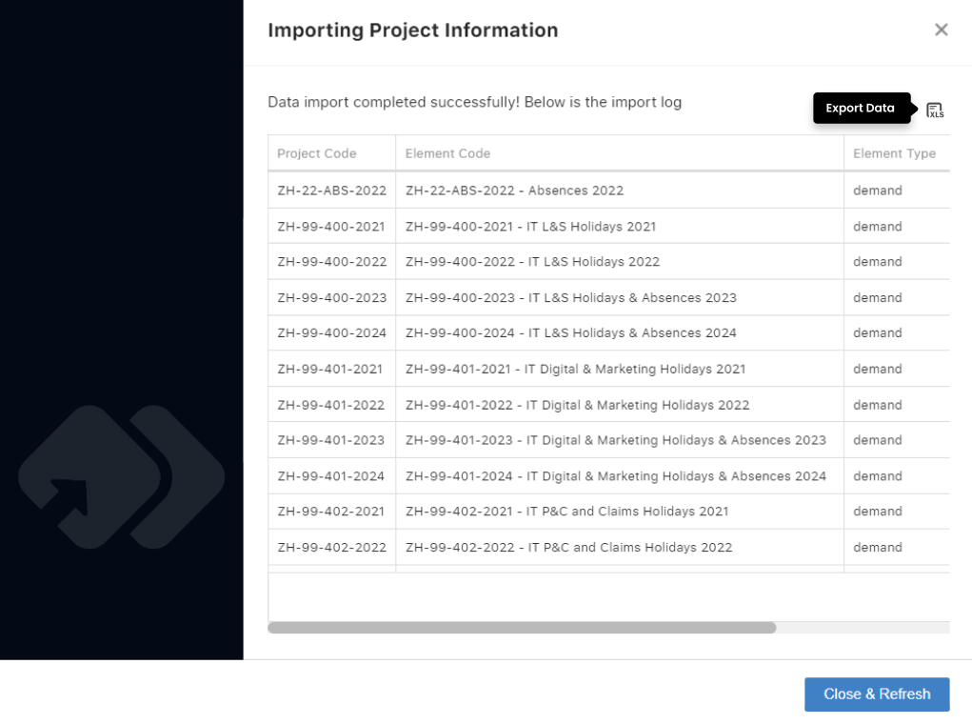

**Message Control:**

Users will receive appropriate messages based on the import process's status, ensuring clear communication and transparency throughout.

